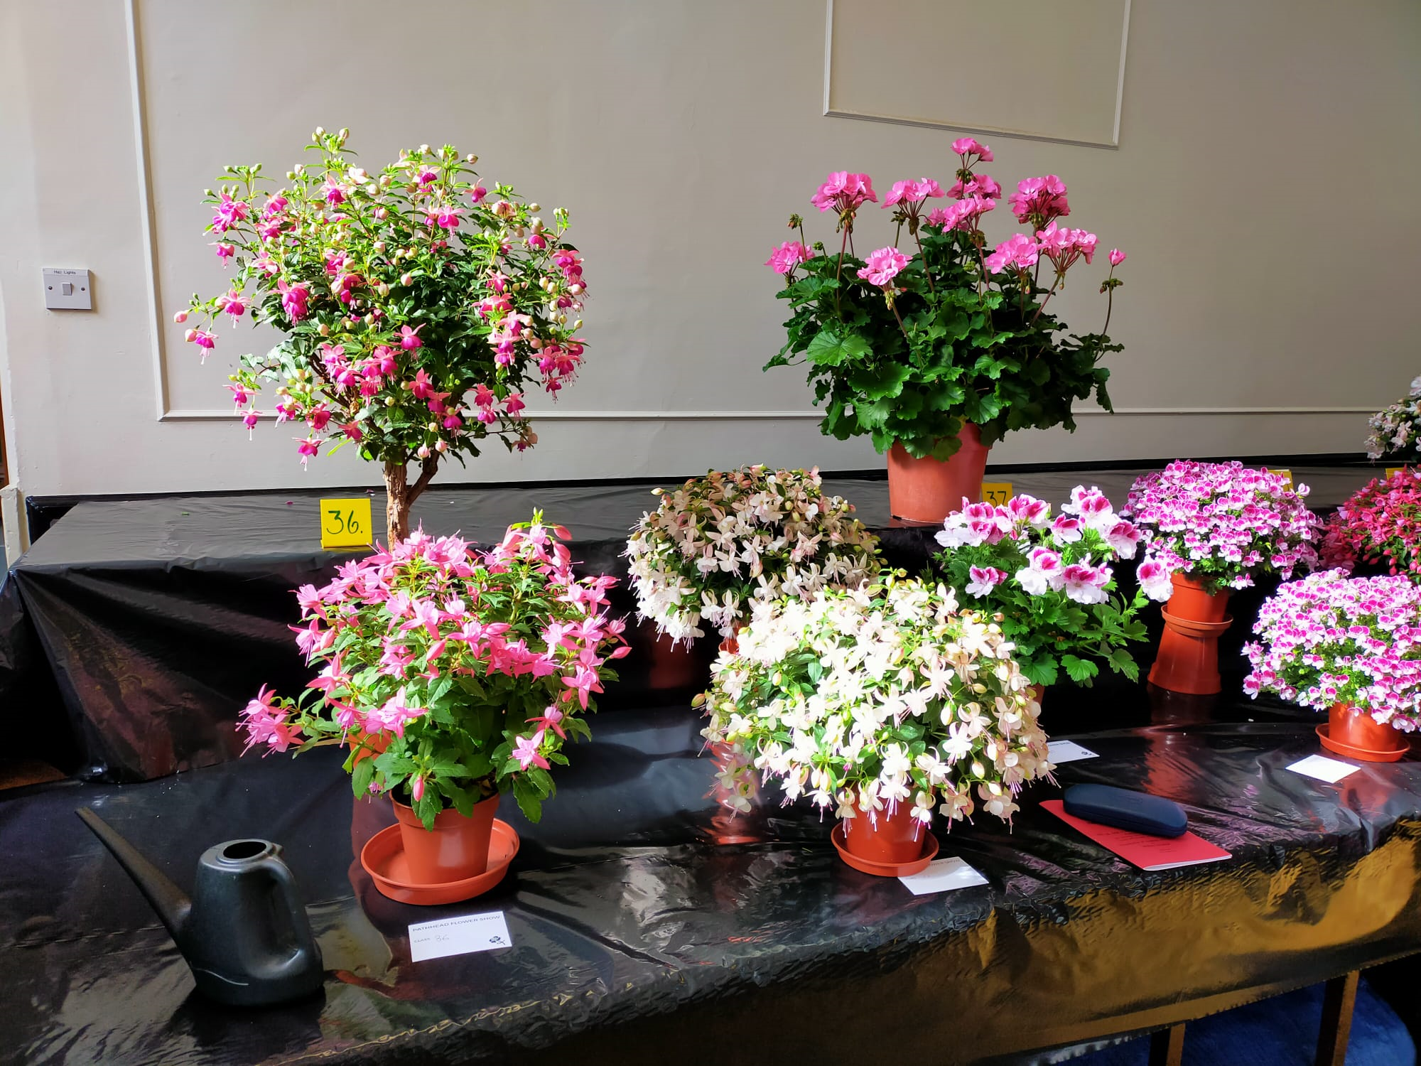

Pathhead and District
Horticultural Society
73rd Annual Flower Show

Will be held on Saturday 30th August 2025
in the Community Hall, Pathhead

Doors open at 2pm
Presentation of trophies at 3.00pm
by Arlene Stuart

TV & Radio Presenter

Admission: By donation
Patrons
The Hon. Mrs. C. J. Dalrymple

Honorary Members

Mr. W McCormack
Mr. A. Rae
Mrs. E Blackadder
Mr. R Miller
Mrs. L Miller

Office Bearers
President
Mr. Jim Williams 07773 878046

Vice President
Mr. W. McCormack 01875 320074

Show Manager
Mr. Jim Williams 07773 878046

Treasurer
Mr. B Christie Tel: 01875 320078

Arts and Crafts Convener
Mrs. M. Winthrop Tel: 01875 320947

Membership Secretary
Mrs. Jen Montgomery Tel: 01875 320280

Programme & Website Secretary
Mrs. Brenda Ritchie Tel: 01875-320819

Committee
Mrs. Aileen Banks, Mr Peter Banks Mrs. Erica Blackadder, Mr. Tony Forrest, Mrs. Helen Gilmour, Mrs. Fiona Meikle, Mrs Mabel McDowell, Mr. J Raeburn
Mrs. Julie Wightman

We are very grateful for the continued financial support for the annual flower show from the Scottish Mining Welfare Trust
CONSTITUTION

- The Society shall be called “Pathhead and District Horticultural Society”.
- The Society shall be under the management of a President, Vice President, Secretary, Treasurer, Show Manager and a Committee (six to form a quorum), who shall be elected for a fixed term of 2 years and shall be eligible to seek re-election if they so wish.
- The committee shall have the power to add to their numbers.
- Membership £5.00 (January to December) by annual subscription.
Life membership £50 by single payment.
Honorary membership by invitation of the management committee.
- For the confined classes, intending competitors must reside and exhibits must be grown within the districts of Crichton, Cranstoun, Ford, Humbie and Fala.

This restriction does not apply to those competing in the open classes.

A.G.M. Tuesday 11th November, 2025 at 7.30pm in the
Sports Pavilion, Pathhead

RULES
- Entries free to members and children.
- All entries should be received by the Show Manager before 9.30am on the day of the show.
- Entry cards, upon which the Competitor shall write his/her, name and address, will be placed by the exhibit, showing the class number only. Cards will be supplied.
- Experienced judges shall be appointed and their decision will be final.
- No prize will be awarded for any exhibit which is not in accordance with the Schedule. The judges are empowered to withhold prizes from any exhibit which may be of insufficient merit. Exhibits to be judged on quality, except where otherwise stated.
- The Hall will be open for staging of exhibits between the hours of 7.00pm and 9.00pm on Friday and 7.00am until 9.30am on the Saturday of the show. NO EXHIBITS ACCEPTED AFTER 9.30 AM
- Protests must be lodged with the Show Manager in writing no later than 3pm on the day of the show before a protest can be considered.
- No exhibitor, when competing, will be allowed to submit more than one entry for the same prize.
- No exhibits to be removed before the closing hour – 4.00pm.
- Each exhibitor must sign the Declaration on the entry form, that the products exhibited in the Horticultural Section are bona fide his/her own growth, and have been in his/her possession for at least four months previous to the day of the Show. (Flowers for Decorative Section excepted). Handicraft exhibits must not have been previously exhibited at this Show and must be the exhibitor’s own work.
- Anyone infringing any of the rules shall be liable to forfeit all subscriptions paid; prizes gained, and may be expelled by the Society.
- Prize money will be paid out in the Community Hall, Pathhead, on the day of the show from 3.00pm until 4.00pm

AWARDS FOR 2025 – WINNERS FOR 2024
Class 69 Pathhead Premier Award Mr. A Banks
The Dr Alexander Laurie Quaich – Class 37 Mr. W. Punton
The Dr Colin Hogg Trophy for Tallest Sunflower Anna Gowans
The “Callander Cup” for Best General Garden in the District Mrs Bertram
The “Rosemains Rose Bowl” for Most Points in the Open Classes 34-100 Mr. J Williams
The “Roderick Murchison” Trophy for Most Points in Confined 1-23 Mrs. Sana Forrest
The “Cranstoun Trophy” for Best Chrysanthemum Exhibit. No Award
The “Society’s Trophy” for Best Dahlia Exhibit (Open) Mr. D Rogerson
The “CraikTrophy” for Best Cut Flower Exhibit in Confined Classes 1-16 Mrs. S. Forrest
The “Society’s Trophy” for Best Vegetable Exhibit in Confined 17-23 Mrs B Ritchie
The “Logan Vase” for Class 14 Aileen Banks
The “Scott Trophy” for Best Exhibit in Decorative Classes Aileen Banks
The Society’s Rose Bowl” for Most Points Industrial Classes 106-118 Lizzie DeBechi
The “George Moir” Rose Bowl for Best Exhibit (Handicrafts) 119-128 Christine Donaghue
The Society’s Trophy Most Points in 119-128 Christine Donaghue
The “Society’s Trophy” for Best Exhibit (Cookery) Classes 106-118 Lizzie DeBechi
The “Corsar Trophy” for Most Points gained by a Two-Person Family in
Horticultural and Industrial Sections. Open Classes included (min qualification,
7 entries in each section) Each person must obtain at least 3 points Mr & Mrs P Banks

The “Wahlberg Trophy” for Best Overall Exhibit in the Show Christine Donaghue
The “Chalmers Trophy” for Class 15. Single Rose Mrs Sana Forrest
The “Davidson Trophy” for Best Pot Plant Mr. A Banks
The “Dr Ireland trophy” for Best Bowl of Roses Mr. A. Banks
The “Chesterhill Cup” for members of the SWI Mrs M Winthrop &
Mrs A Gordon
The “Callander Trophy” Silver Teapot Christine Donaghue
The “Dalrymple” Special Prize for Children most points 130 – 131 Ruardh Owen &
Tara Else
The “Lamb Cup” for Best Exhibit classes 132 - 133 Summer Forrest
The “Wallace Shield” for Best Exhibit Summer Forrest
The “Royal Bank Trophy” Class 129 No Award
The “Katie Trophy” Class 76 Mr. J Williams
Pathhead Sports and Social Trophy Class 47 Gladioli Mr. A Banks
Garden News Top Tray No Award
Garden News Top Vase Mr. A Banks
Fuchsia Trophy – Class 43 Mr. J. Crawford
Jim Park Trophy – Best Vase Spray Chrysanthemums No Award
The Eric Caulton Cacti Trophy – Class 39 Dr S Da Prato
The Mary Callander Golden Jubilee Trophy best entry 146 Lewis Pryde
The Scottish Grass Machinery Cup – Best Lawn Mrs. A Dingle
President’s Message 2025

Dear Members,

Beginning of January, very low temperatures, greenhouse temperature dropping to 7 degrees with heating on, (don’t look at the electricity bills!). Just taken delivery of my bird food (74 kilos), cheapest way to buy it, and in this weather, I go through it fairly quickly. We really need to help our feathered friends, especially the smaller birds who need a constant supply of food and water. I find that if you feed at the same time and place (titbits of mealworms or waxworms) they become very friendly and trusting.

Thinking ahead for my window box display, I found that Argyranthemums did very well last year, and I have ordered some different colours to complement my usual begonias.

Even at this time of year, the tips of the daffodils are popping through, the aconites are in flower, the cymbidium orchids in the conservatory are flowering. Lots to look forward to, and I hope that you all have a busy and productive gardening year.

Best wishes

Jim Williams.

The President and Committee would like to thank all the many people who have so generously made donations to the Society. This support ensures the continuation of the Flower Show and we are truly grateful. The Society would also like to thank those listed below who have donated Special Prizes or sponsored the various classes,

Mrs. M. Winthrop
Mr. W. McCormack

Garden Competitions.

Each year the Callander Cup is awarded to the best garden. A panel will walk round Pathhead and District in August, looking at all the front gardens, and will select those that they consider to be the most colourful, tidy, interesting and best laid out. From these our selected judge will choose the most outstanding to be awarded the cup, and the others will be runners up.

The 2024 winner was Mrs Bertram

The Scottish Grass Machinery Trophy is awarded to the Best Lawn

The 2024 winner was Mrs. A. Dingle

CONFINED CLASSES (See section 5)
CUT FLOWERS

Please note, there will be no prize money in the confined section.

- 1 Vase Annuals or Plants commonly grown as such (1 variety or mixed)
- 1 Vase Hardy Herbaceous (1 variety or mixed)
- 3 Dahlias
- 1 Pot Pansy or Viola
- 1 Large Dahlia (Cactus or Decorative)
- 1 Gladiolus Spike
- 3 African Marigolds
- 5 French Marigolds, 15cm Vase
- 1 Vase Mixed Flowers
- 1 Vase foliage – not more than 3 varieties
- 1 Vase Asters, 5 Blooms
- 1 Vase Sweet Peas
- 1 Vase Floribunda rose (3 stems)
- 4 Rose Blooms The Logan Vase
- 1 Rose Bloom The Chalmers Trophy
- 1 Vase Flowering Shrub

VEGETABLES

- 5 pods peas
- 3 onions grown from sets
- 2 globe beetroot
- 3 stalks of rhubarb
- 4 potatoes, white or coloured
- 5 tomatoes
- 2 courgettes
- 3 types of herbs in a jam jar
- One collection of vegetables, 2 each of 3 cultivars, shown in a box not exceeding 30cms X 48cms.

The Roderick Murchison Trophy – most points in classes 1-25.
The Craik Trophy – Best cut flower exhibit in confined classes.
The Society Trophy – Best vegetable exhibit in confined classes.
OPEN CLASSES

POT PLANTS
Prize’s 1st £1.50 2nd £1, 3rd 50p unless marked otherwise
The Rosemains Rose Bowl – Most Points in Open Classes 33 – 100
The Davidson Trophy – Best Pot Plant

33 Photograph of your hanging basket (2025 date)
34 1 Foliage Plant
35 1 Begonia, tuberous rooted
36 2 Fuchsias £5 £1.50 £1
37 2 Geraniums: The Dr Alexander Laurie Quaich £2.50 £1.50 £1
38 1 Hanging Plant
39 2 Pots Cacti or Succulents: The Eric Caulton Cacti Trophy
40 1 Fuchsia in 13cm pot
41 1 Fern
42 1 Geranium
43 3 Fuchsias in 9cm pots. The Fuchsia Trophy £2.50 £1.50 £1
44 1 Patio container/pot
FLOWERS
The Pathhead Sports and Social Trophy – Gladioli- class 47
The Jim Park Trophy – Best vase Chrysanthemums
The Society’s Trophy - Best Dahlia exhibit
The Dr Ireland Trophy – Best Bowl of Roses

45 1 Vase Hardy Herbaceous, 1 Variety or mixed
46 1 Vase Annuals grown as such, 1 Variety or mixed
47 2 Vases Gladioli, 3 spikes each vase
48 1 Vase Gladioli, 2 spikes
49 1 Vase Gladiolus, 1 spike
50 1 Vase Chrysanthemums, 3 blooms
51 1 Vase Spray Chrysanthemums
52 1 Vase mixed foliage (can include berries)
53 2 Vases Spray Chrysanthemums
54 1 Vase Cactus Dahlias, medium, 3 blooms
55 1 Vase Cactus Dahlias, small, 3 blooms
56 1 Vase Decorative Dahlias, medium, 3 blooms
57 1 Vase Decorative Dahlias, small, 3 blooms
58 1 Vase Pompon Dahlias, 5 blooms
59 1 Large Dahlia
60 1 Vase Asters, 5 blooms
61 1 Vase Antirrhinums, 5 spikes
62 2 Vases Sweet Peas, 6 spikes in each vase
63 1 Vase Sweet Peas, mixed, 6 spikes.
64 4 rose blooms
65 1 rose bloom
66 Bowl of roses, own bowl
67 6 French marigolds on a board
68 6 Pansies on a board
69 1 Pot Plant & Vase of Flowers, Pathhead Premier Award £20 £10 £5

VEGETABLES

70 3 Dessert Apples
71 3 Cooking Apples
72 5 Pods Peas
73 5 Pods Broad Beans
74 5 Pods French Beans
75 5 Runner Beans
76 3 Onions from plants, 3 Onions under 12” from
Plants, 3 onions from setts. The Katie Trophy £5 £3 £2
77 3 Kelsae Onions
78 3 Onions under 12” circumference, from plants
79 3 Onions from setts
80 5 Shallots, pear shaped
81 5 Shallots, red or yellow, not pear shaped
82 1 Cauliflower
83 1 Cabbage
84 4 Potatoes, white
85 4 Potatoes, coloured
86 6 Tomatoes
87 1 Truss of Tomatoes, quality, 2 or more ripe.
88 3 Turnips
89 3 Beet, globe
90 3 Carrots, stump rooted
91 2 Carrots, long
92 2 Beet, long
93 2 Parsnips
94 2 Leeks, long
95 2 Celery
96 1 Pot Leek
97 1 Pot Parsley
98 3 Stalks Rhubarb
99 Any other vegetable or fruit, named:
100 Collection of vegetables, 5 kinds, one of each £5 £3 £2
100a Garden News Top Vase class – 2024 competition rules £5 £3 £2

DECORATIVE SECTION
The Scott Trophy for best exhibit in the Decorative classes.
NB No floral foam (Oasis) to be used in this section, as it is harmful to
the environment

101 An arrangement using two colours of flowers, plus foliage
102 An arrangement to include a mirror
103 An arrangement ‘simply green’
104 Fruit, vegetables and herbs arranged in a basket
105 Novice: A jug of garden flowers

COOKERY
The Society’s Rose bowl for most points in classes 106-118
The Society’s Trophy for best exhibit in classes 106-118

Prize’s 1st £1.50 2nd £1 3rd 50p

106 3 Cheese scones
107 3 Pancakes
108 3 Oatcakes
109 Fruit gingerbread
110 3 Butterfly cakes
111 Loaf Soda bread
112 A small dish savoury pate
113 Jar of jam, any flavour
114 Jar of marmalade – any flavour
115 Jar of chutney - any flavour
116 3 pieces shortbread
117 Lemon Drizzle Cake (MEN ONLY)
118 6 Eggs (from your own hens)

Please make certain that entry cards are securely attached to each item.
HANDICRAFTS

The George Moir Rose Bowl for best exhibit in classes 119-128.
The Society’s Trophy for most points in classes 119-128.
The Callander Silver Teapot – Senior Citizen

119 Premature baby jacket – to be donated
120 A Crochet item
121 A piece of handmade jewelry
122 A tote bag made from recycled material
123 2 metres of bunting
124 A birthday card - any craft
125 A Christmas tree decoration – any craft
126 A photograph of a gate
127 A photograph of a seascape
128 A painting of a landscape, any medium, framed or unframed

Please ensure that the entry cards are securely attached to each entry.

129 ROYAL BANK TROPHY £3 £2 £1

Item made from any craft other than above

130 Chesterhill cup – W.R.I. Competition £3 £2 £1

Cappuccino cake - recipe given Page 14

PLEASE READ THE RULES

Membership fee for 2025 is £5.

Postal entries to the Show Manager (07773 878046)

All exhibits not entered on this form may be disqualified

I hereby declare that the entries I intend to exhibit at the above show do conform to the Regulations

contained in this Schedule to which I agree…………………………………………………Signed

NAME………………………………………………………………………………………………………….

ADDRESS……………………………………………………………………………………………………….

…………………………………………………………………………………………………………..

DATE …………………………………………………………………….

List of Prizes gained

This form must be completed and handed to the treasurer before any prize money can be claimed.

Name: ……………………………………………………………………………….
Address: ………………………………………………………………………….
…………………………………………………………………………………………..

Total prize monies gained and received £ ……….

Signed …………………………………………………………

Date ……………………………...................

CHILDREN’S COMPETITIONS

Confined to children under 13 years of age

Some useful information and guidance when
entering any classes for your age group

If you are 8 years or under, the more classes you enter, the more points you may gain to give you a chance to compete for the Dalrymple Special Prize.

Class 145: Grow your own Sunflower. Every year we supply sunflower plants for you to grow in your own garden. The tallest one wins the “Dr. Colin Hogg Trophy”. You can get a plant if you come to the Plant Sale on Saturday 10TH May. The plants will be measured during the middle of August.

Class 146: Grow Your Own Potatoes
At the same Plant Sale, you can get a bag and a tuber to grow your own potatoes. You have to put some compost into the bag with the potato and water it well. Remember to keep the compost moist but do not over-water. During the last week in August, we will weigh the potatoes and the heaviest will be the winner, receiving the “Mary Callander Golden Jubilee Trophy “.

Children’s sunflower competition

The 2024 winners of the Sunflower Competition were

GOLD Anna Gowans
SILVER Sydney Jane
BRONZE Isla Gowans

CHILDREN’S COMPETITIONS
(Confined to children under 13 years of age)
No entry fees. Please show age on exhibit.
The Dalrymple Special Prize for child with most points in classes 131-132
The Wallace Shield for best exhibit.
The Lamb Cup for best exhibit in classes 133-136

PRIZE’S 1st £1 2nd 50p 3rd 30p

A – FOR CHILDREN aged 8 years and under
131 Draw a rainbow on a paper plate
132 A decorated digestive biscuit

B – FOR CHILDREN aged 9 years and over but under 13 years
133 A photograph of an animal
134 A drawing of a super hero

145 Children’s Sunflower Competition – “Dr Colin Hogg Trophy”

Last year’s winners, 2024, were
1st Anna Gowans
2nd Sydney Jane
3rd Isla Gowans

146 “The Mary Callander Jubilee Trophy” – grow your own potatoes in a bag.
The Winner is the person with the heaviest weight of potatoes.
Judging will be in the last week of August
Last year, 2024 the prizes for this class were won by:
1st Lewis Pryde
2nd Isla Gowans
3rd Anna Gowans

COLLECT YOUR FREE PLANTS AND POTATOES AT THE PLANT SALE – SATURDAY 10TH MAY IN PATHHEAD PAVILION

13
Class 130 Cappuccino cake Recipe

50gms (2oz) cocoa powder
6 tablespoons boiling water
3 eggs
60ml (2fl oz) milk
175gms (6oz) self raising flour
1 rounded teaspoon baking powder
100gms (10oz) caster sugar

Method:
Lightly grease 2 deep loose bottom sandwich tins and line with baking parchment paper. Pre-heat the oven to 180c/350f/gas mark 4
Put the cocoa powder into a large mixing bowl, add the boiling water and mix well until it has a paste like consistency. Add all the remaining ingredients to the bowl and whisk with a hand held electric mixer until just combined. The mixture will be a thickish batter (careful not to over whisk). Divide the cake mixture between the prepared tins and gently level the surface. Bake for 20-25 minutes until the cakes are well risen and beginning to shrink away from the sides of the tin, turn the cakes out onto a wire rack and leave to cool completely.

To finish the cake:
Butter icing
75g (3oz) butter softened
250g (9oz) icing sugar
1.5 teaspoons instant coffee dissolved in 1.5 tablespoons hot water

For the butter icing, put the butter, icing sugar and dissolved coffee into a bowl and mix well until evenly blended.
To finish the cake use half the icing to sandwich the two cakes together. Spread the remainder over the top. Gently smooth the surface with a palette knife and dust with sifted cocoa power or drinking chocolate.

